Name: B.Srujan Hall ticket No: 2303A51805 Batch: 26
SCHOOL OF COMPUTER SCIENCE AND ARTIFICIAL INTELLIGENCE |  |  |  |  | DEPARTMENT OF COMPUTER SCIENCE ENGINEERING
Program Name: B. Tech |  |  |  | Assignment Type: Lab |  |  | Academic Year:2025-2026
Course Coordinator Name |  |  |  | Dr. Rishabh Mittal
Instructor(s) Name |  |  |  | Mr. S Naresh Kumar  Ms. B. Swathi  Dr. Sasanko Shekhar Gantayat  Mr. Md Sallauddin  Dr. Mathivanan  Mr. Y Srikanth  Ms. N Shilpa  Dr. Rishabh Mittal (Coordinator)  Dr. R. Prashant Kumar  Mr. Ankushavali MD  Mr. B Viswanath  Ms. Sujitha Reddy  Ms. A. Anitha  Ms. M.Madhuri  Ms. Katherashala Swetha  Ms. Velpula sumalatha  Mr. Bingi Raju
CourseCode |  |  | 23CS002PC304 | Course Title |  | AI Assisted Coding
Year/Sem |  |  | III/II | Regulation |  | R23
Date and Day  of Assignment |  |  | Week9 – Wednesday | Time(s) |  | 23CSBTB01 To 23CSBTB52
Duration |  |  | 2 Hours | Applicable to  Batches |  | All batches
Assignment Number:17.3(Present assignment number)/24(Total number of assignments)
 | Q.No. | Question |  |  |  |  |  | Expected Time  to complete
 | 1 | Lab 17 – AI for Data Processing: Data Cleaning and Preprocessing Scripts  Lab Objectives:  - Learn how to clean raw datasets using AI-assisted Python scripting.  - Apply preprocessing techniques such as handling missing values, encoding categorical data, and normalization.  - Automate repetitive data-cleaning tasks with AI-generated code.  - Understand how preprocessing impacts model performance.  Task 1 Employee Dataset Cleaning  Task:  Use AI assistance to clean an employee information dataset.  Instructions:  - Handle missing values in salary, designation, and experience  - Remove duplicate employee IDs  - Standardize text values (job titles in lowercase)  - Encode categorical features (designation, employment_type)  Expected Output:  A clean dataset suitable for HR analytics and prediction tasks.  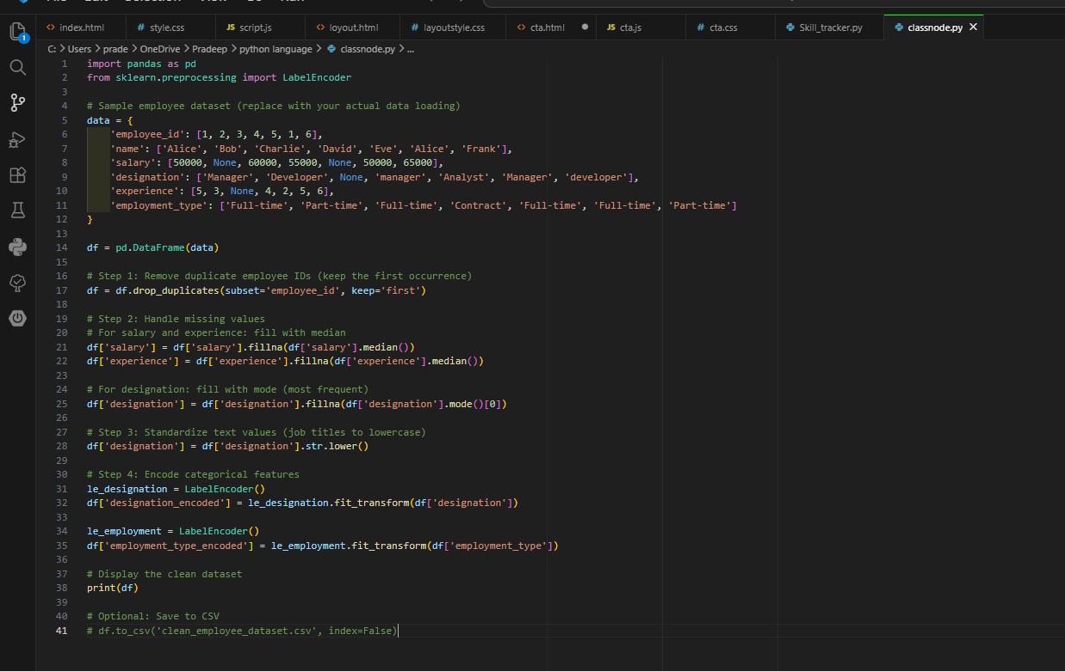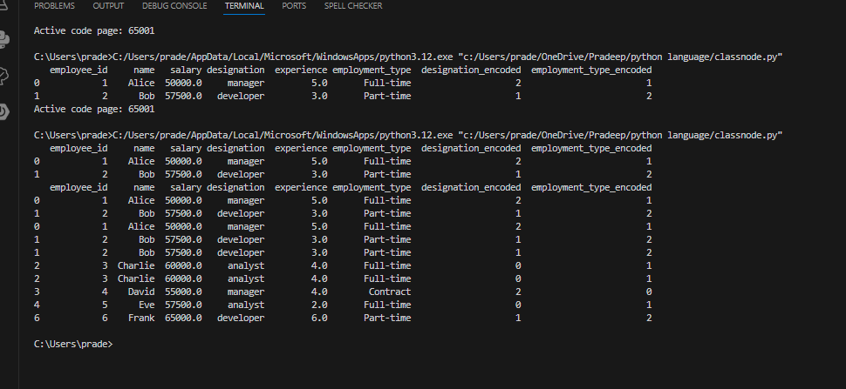  Task 2 – Student Performance Data Preprocessing  Task:  Preprocess student performance data using AI assistance.  Instructions:  - Convert exam_date column into datetime format  - Extract new features (month, semester, day)  - Normalize total_marks  - Detect and handle outliers in marks using IQR or Z-score  Expected Output:  A transformed dataset with time-based academic features and normalized marks.  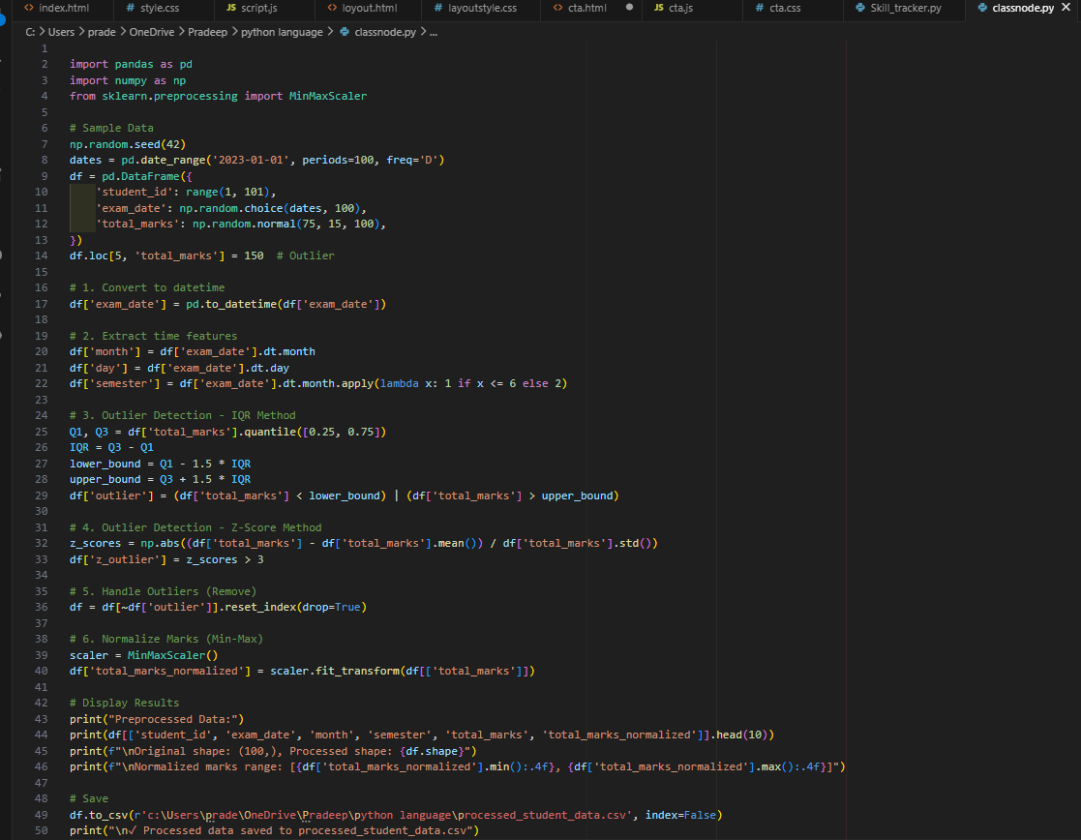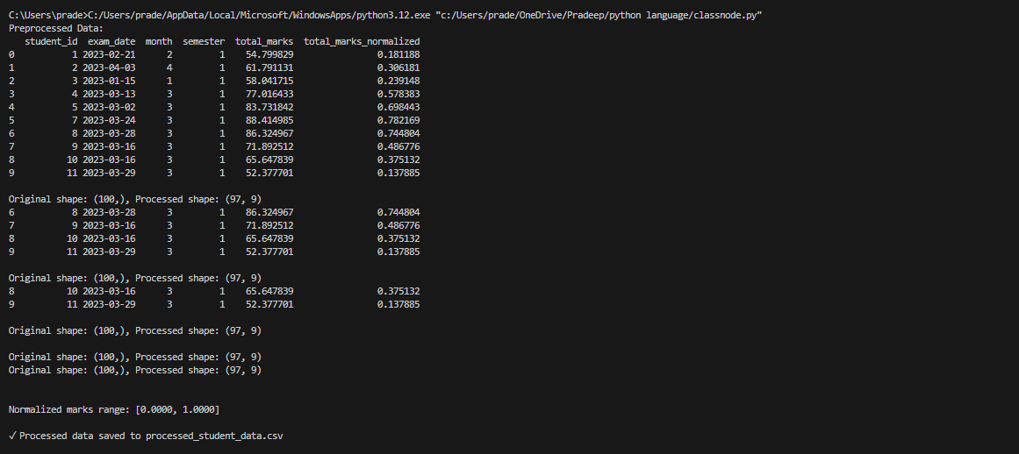  Task 3 – Student Health Data Preparation  Task:  Clean and preprocess student health records using AI scripts.  Instructions:  - Handle missing values in height, weight, BMI  - Encode categorical features (medical_condition, fitness_status)  - Scale numerical features using standard scaling  - Split dataset into training and testing sets  Expected Output:  A preprocessed dataset ready for predictive health analysis.  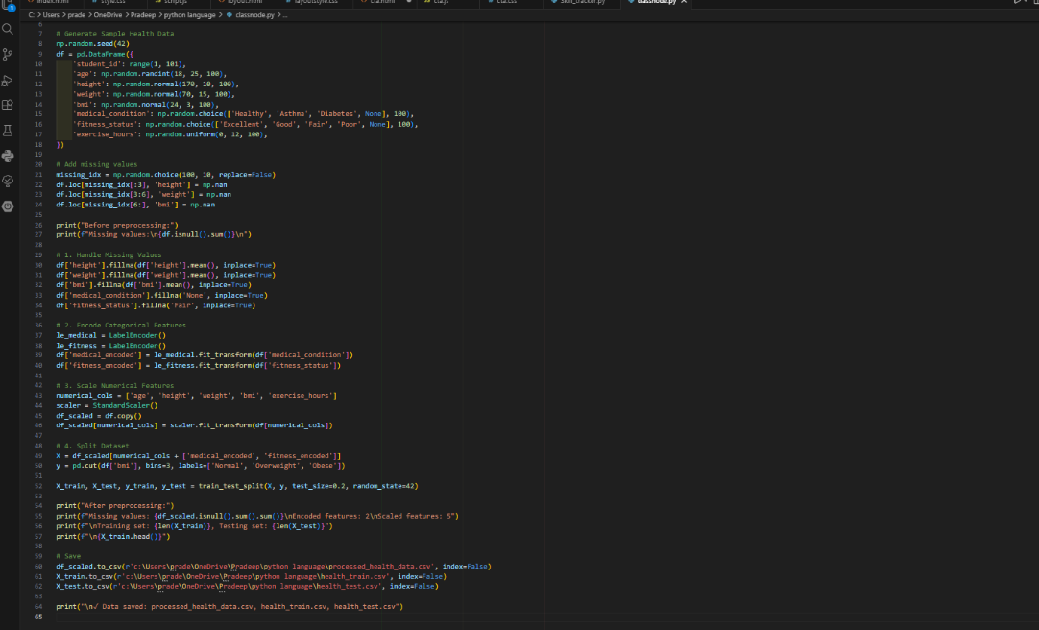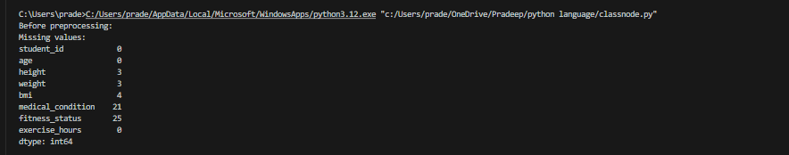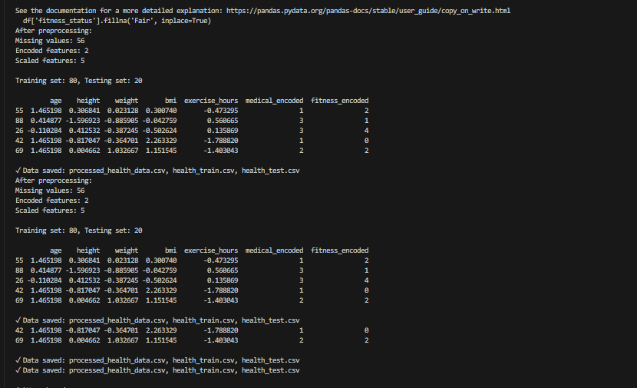  Task 4: Real-Time Application: Ride-Sharing Data Cleaning  Scenario:  A ride-sharing company has trip data with errors.  Requirements:  - Standardize pickup and drop locations  - Fill missing fare amounts with median values  - Remove duplicate ride entries  - Normalize driver ratings  - Generate a summary of data improvements  Expected Output:  A clean dataset ready for operational analysis.  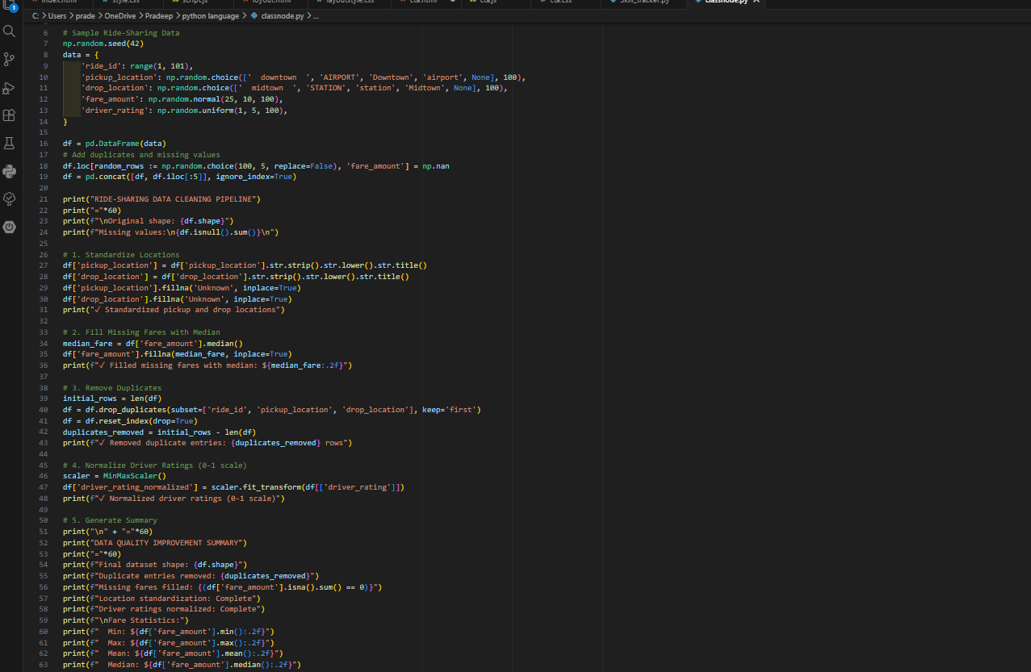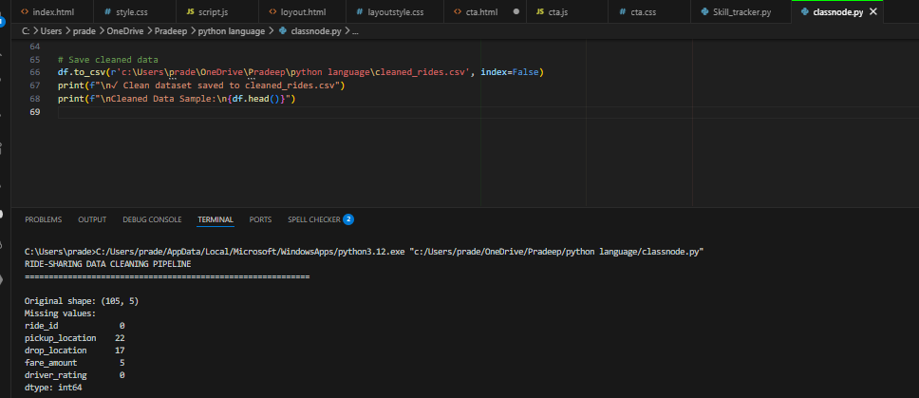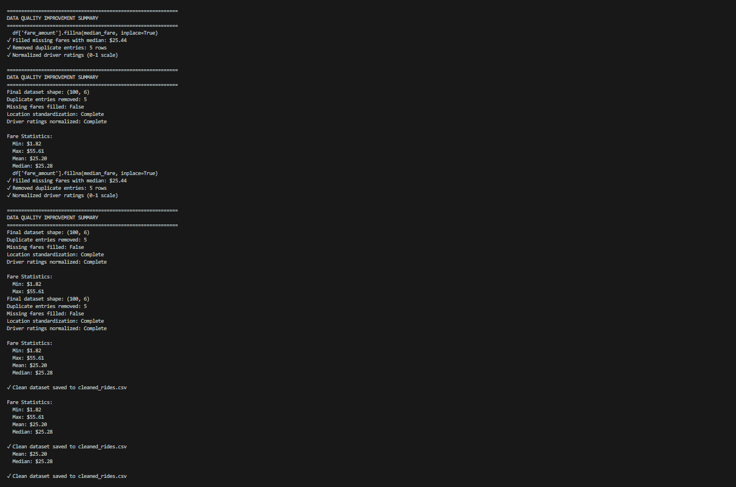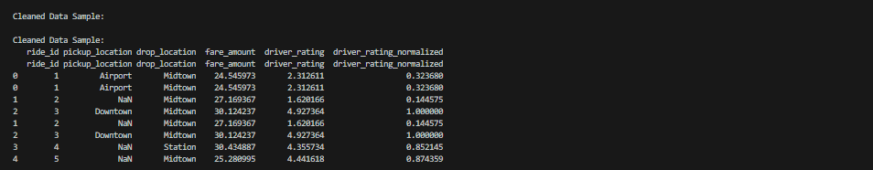  Note: Report should be submitted as a word document for all tasks in a single document with prompts, comments & code explanation, and output and if required, screenshots. |  |  |  |  |  | Week9 - Wednesday

